**Sobel Edge Detection**

This project continues the recent trend of the difficulty coming from integration. I believe I’ve heard it colloquially referred to as “integration hell” and I found the term apt during this assignment. The difficulties I encountered did end up forcing me to create a local library of all of my functions as well as to rework some of them so they can be more widely used. I thankfully was able to complete the assignment, though I’m sure my code has inefficiencies.

Horizontal Mask

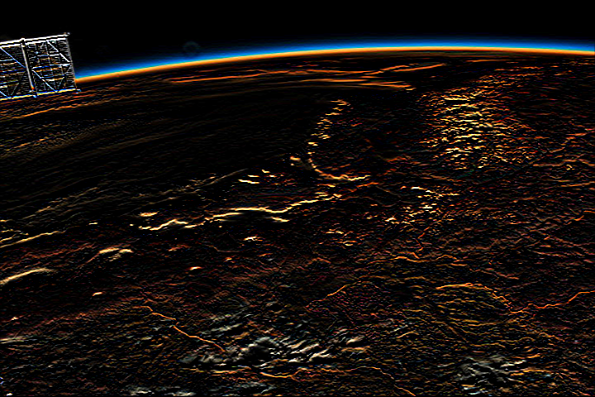

Vertical Mask

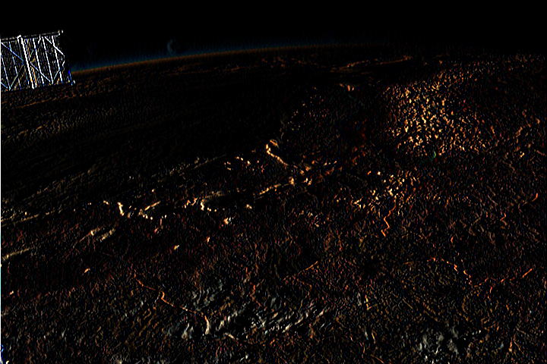

Magnitude

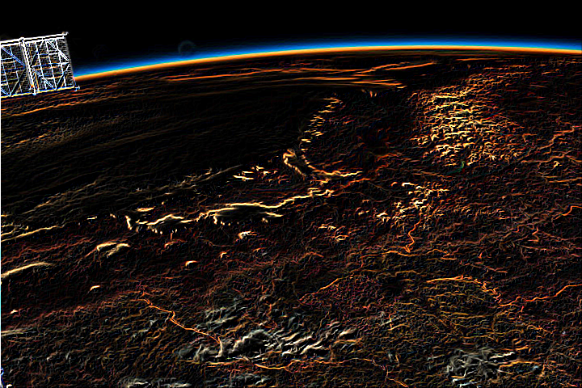

Orientation

